Raheny Business Association Annual General Meeting
Held by Zoom on Tuesday 26th January 2021 at 8.00 pm.

In Attendance

Committee Members | Co-Chair | Claire Kenny  Ross Tully
 | Hon Treasurer | Michael Duffy
 | Hon Secretary | John Meade
 | Coordinator | Barry Murphy
 | From RTVG | Con Clarke  Robert Bishoff  Aidan Fitzsimons  John Gaffney  Fiona Freyne
Members | Raheny Shamrock | Dick Hooper
 | Wicked Waxes | Linda Hogan
 | RLM | Padraic Clarke
 | Grangepark Print | Claire McCarron
 | Raheny Vets | Helen Keating
 | EBS | Ronnie Flood
 | Make Health your Business | Anna O’Leary
Business | The Watermill | Orla Brennan
 | Therapist/Counsellor | Margaret Mara

Chairperson’s Address:

Claire gave a detailed roundup of all that has happened in Raheny over the last 12 months, particularly from the time of the first lockdown in Mid-March 2020.

Claire also lamented on the very sad passing of our friends and fellow Committee Members Seamus Griffith and Pat Hooper and the great effort they both made not only into the Raheny Business Association, but also Raheny Tidy Village and Raheny Shamrock A.C.

Treasurer’s Report – Michael Duffy asked John Meade to guide the attendance through the accounts of the RBA for the year ended 31st December 2020. The overall Income and Expenditure Accounts was as follows:

 | 2020 | 2019
 | € | €
Total Income | 20,328 | 31,907
Less Expenditure | 21,541 | 29,194
(Deficit) Surplus | (1,213) | 2,713

Not surprisingly the Association had a small deficit in 2020.

The main drop in both Income and Expenditure related to the flowers where they were not utilised this year due to both Covid and Issues with supply.

€2,538 was expended on Coronavirus printing and signs.

The Balance Sheet as at 31st December 2020 shows reserves as follows:

 | 2020 | 2019
 | € | €
Associations Capital Account | 2,708 | 3,921

The drop in reserves of €1,213 related to the deficit in the Income and Expenditure Account of €1,213.

Election of Committee -

All are sad to see Jacqui Cheevers and Auveen Bell retiring, Claire Kenny thanked both for their great service to the RBA. All other Committee Members offered themselves for re-election and all were duly re-appointed.

Election of Accountant –

J. Meade and Company offered themselves for re-election and were duly re-appointed.

Any other Business –

There were no other items listed or brought up under Any other Business. There being no further business the meeting was duly closed by Claire Kenny.

Signed:

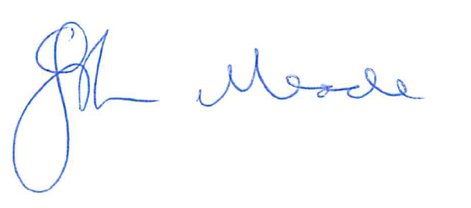
John Meade - Hon Secretary

